Modelling Project

James Fulford

# Motivating Question:

How do small Facebook Pages grow organically?

Answer: after huge growth when a page is first created, pages tend to grow extremely slowly.

# Dataset Overview:

Collected are eight datasets, each with metrics pertaining to the Facebook page of a small non-profit. Data was collected in a 12 week period (maximum Facebook would allow at one time) starting on 11/8/2016.

# Lifetime Total Likes (by Week)

In Column B of the eight included datasets is the Lifetime Total Likes. Of all these datasets, two of them represent pages that were started in the 12 week period: sets 2 and 6.

The two pages that were created in the period studied grew extremely quickly in the first week, then proceeded to have only slightly higher growth than the established pages. After a page’s first week, it seems growth is pretty much flat.

## Naïve Model: Line

So, lines were fit to the observations which occurred after a page was created. Below are the parameters and r2 values for each model.

|  |  |  |  |
| --- | --- | --- | --- |
| **Dataset** | **Slope** | **Y-intercept** | **r2** |
| 1 | 0.32 | 816.93 | 0.3442 |
| 2 | 2.25 | 195.75 | 0.9709 |
| 3 | 0.09 | 43.52 | 0.5432 |
| 4 | 0.86 | 168.7 | 0.7279 |
| 5 | 5.21 | 21.64 | 0.8486 |
| 6 | 9.01 | 431.74 | 0.808 |
| 7 | 0.77 | 887.62 | 0.625 |
| 8 | 0.37 | 392.5 | 0.9491 |

In the graph below, the dotted lines represent true observations, whereas the models are solid lines.

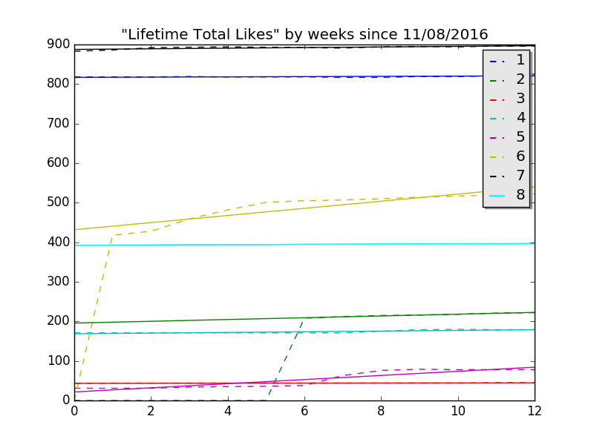

## Naïve Pessimistic Model: Logistic

Logistic curves (with lower bound at the lowest value, and not fit to data representing when pages did not exist yet) seem to fit datasets 5 and 6 more effectively.

These models suggest an upper limit to growth of each page, hence the pessimism.

|  |  |
| --- | --- |
| **Dataset** | **Projected Maximum Likes** |
| 1 | 462263 (thinks curve hasn’t hit growth spurt) |
| 2 | 216 (handles growth spurt weirdly) |
| 3 | 44 |
| 4 | 179 |
| 5 | 78 |
| 6 | 514 |
| 7 | 893 |
| 8 | 396 |

